"ASIAN-CARGO LINK"

CATALOG

Optical Power Splitting Series PLC splitters
PLC splitter is a type of optical power management device that is fabricated using silica optical waveguide technology. Flyin Optronics provides whole series of 1xN and 2xN splitter products that are tailored for specific applications. All products meet GR-1209-CORE and GR-1221-CORE requirements.

Features

- Low Insertion loss

- Low PDL

- Compact Design

- Good channel-to-channel uniformity

- Wide Operating Wavelength: From 1260nm to 1650nm

- High Reliability and Stability

Applications

- FTTX Systems

- PON Networks

- CATV

- Optical Signal Distribution

Specifications (1XN)：

Parameters | 1×2 | 1×4 | 1×8 | 1×16 | 1×32 | 1×64 | 1×128
Operating wavelength | 1260 ~1650nm
Insertion Loss (dB)（P/S Grade） | 3.6/4.3 | 7.0/7.4 | 10.1/10.7 | 13.3/13.5 | 16.5/16.9 | 19.9/20.5 | 23.8/24.5
uniformity (dB) | 0.6 | 0.7 | 0.8 | 1.0 | 1.5 | 2 | 2.5
PDL (dB) | 0.2 | 0.2 | 0.3 | 0.3 | 0.3 | 0.3 | 0.5
Return Loss (dB) | ≥55
Directivity (dB) | ≥55
TDL(dB) | 0.5
Operating/Storage Temperature (℃) | -40～85

Specifications (2XN)：

Parameters | 2×2 | 2×4 | 2×8 | 2×16 | 2×32 | 2×64 | 2×128
Operating wavelength | 1260 ~1650nm
Insertion Loss (dB)（P/S Grade） | 4.0/4.5 | 7.2/7.7 | 10.5/11 | 13.7/14.5 | 17/17.8 | 21/21.5 | 25/25.5
uniformity (dB) | 0.8 | 1.0 | 1.0 | 1.5 | 2.0 | 2.5 | 2.5
PDL (dB) | 0.2 | 0.2 | 0.3 | 0.3 | 0.3 | 0.4 | 0.4
Return Loss (dB) | ≥55
Directivity (dB) | ≥55
TDL (dB) | 0.5
Operating/Storage Temperature (℃) | -40～85
Note: All the data above does not include connector

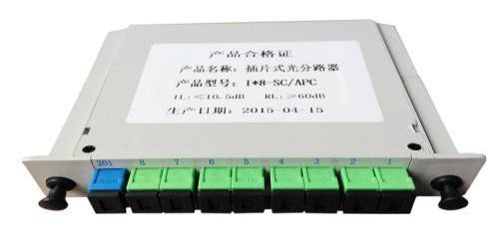 | 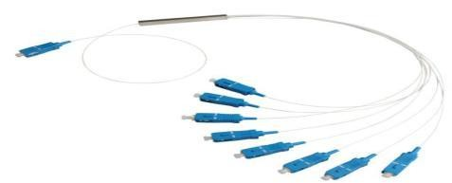 | 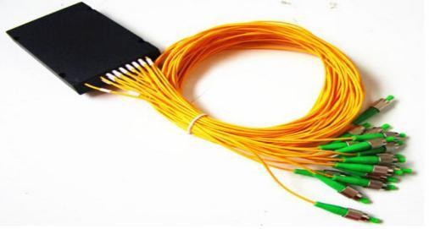
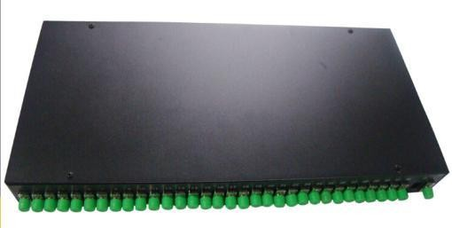 | 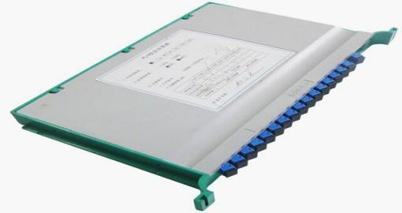 | 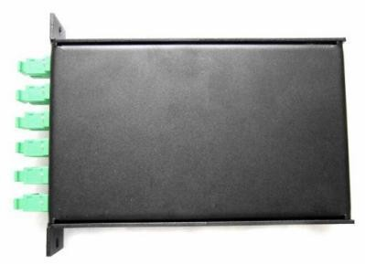

FBT Optical Coupler-SM

Features
- Low Insertion loss

- Various Coupling Ratio

- Compact Size
Applications
- Long-haul Telecommunications

- CATV Systems & Fiber Sensors

- Local Area Network

Coupling Ratio | Insertion Loss（dB）
 | Tap | Signal
50/50 | 2.8-3.6 | ≤3.6
45/55 | 3.3-3.9 | ≤3.0
40/60 | 3.8-4.5 | ≤2.6
35/65 | 4.2-5.0 | ≤2.2
30/70 | 4.6-5.7 | ≤1.9
25/75 | 5.8-6.7 | ≤1.6
20/80 | 6.7-7.6 | ≤1.2
15/85 | 7.8-9.0 | ≤0.98
10/90 | 9.3-11.0 | ≤0.63
5/95 | 12.4-14.0 | ≤0.41
1/99 | 18.6-21.0 | ≤0.25
Excess Loss(Typ.)（dB） | 0.10

PDL(Max.)（dB） | 0.15
Operating Wavelength | 1310±40, 1550±40,1310/1550±40,1310/1550/1490±40 or custom
Directivity（dB） | ≥55
Port Configuration | 1×2 or 2×2
Note: All the data above does not include connectors

Specifications:

Note: All the data above does not include connectors.

Parameter | Unit | Specification
Operating Wavelength | nm | 1310±40, 1550±40,1490±10
(1×N)(2×N) |  | N=3 | N=4 | N=5 | N=6 | N=8 | N=10 | N=16 | N=24 | N=3
Fiber Type |  | Corning SMF-28e
IL(MAX) | dB | 5.6 | 7.1 | 8.3 | 9.2 | 10.6 | 11.75 | 14.4 | 15.6 | 17.4
Uniformity | dB | 0.5 | 0.7 | 1.1 | 1.3 | 1.5 | 1.7 | 1.8 | 2 | 2.2
Return Loss | dB | ≥55
Directivity | dB | ≥55
PDL | dB | 0.2 | 0.2 | 0.3 | 0.3 | 0.3 | 0.3 | 0.4 | 0.5 | 0.5

FBT Optical Coupler-MM

Specifications:

Parameter | Insertion Loss（dB）
Test Wavelength (nm) | 1310 |  | 850
Splitting Ratio | Tap | Signal | Tap | Signal
50/50 | 3.0-4.1 | ≤4.1 | 3.0-4.1 | ≤4.1
40/60 | 4.3~5.4 | ≤3.0 | 3.8~4.9 | ≤3.4
30/70 | 5.1~7.0 | ≤2.3 | 4.9~6.4 | ≤2.4
20/80 | 7.2~9.4 | ≤1.65 | 6.3~8.1 | ≤1.9
10/90 | 9.8~14.5 | ≤1.15 | 8.3~11.5 | ≤1.4
1/99 | 19.1-22.3 | ≤0.70 | 16.8-21.5 | ≤0.75
Operation Wavelength(nm) | 850±40, 1310±40,850/1310±40

Directivity（dB） | ≥40
Operating Temperature | -20～+70℃
Storage Temperature | -40～+85℃
Note: All the data above does not include connectors.
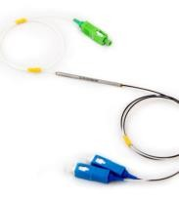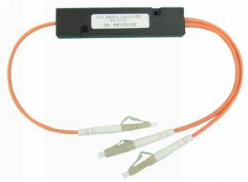

Parameter | Unit | Specification
Fiber Type |  | Corning MMF 62.5/125um or 50/125um
(1×N) |  | N=3 | N=4 | N=5 | N=6 | N=8 | N=16
Test Wavelength | nm | 850±40
IL(MAX) | dB | 6.8 | 8.3 | 10.2 | 10.9 | 9.1-12.4 | 12.1-16.5
Uniformity | dB | 1.0 | 1.5 | 2.0 | 2.0 | 2.0 | 3.0
Test Wavelength |  | 1310±40
IL(MAX) | dB | 6.6 | 8.3 | 10.0 | 10.7 | 12.40 | 12.1-16.5
Uniformity | dB | 1.0 | 1.5 | 2.0 | 2.0 | 2.0 | 3.0
Return Loss | dB | ≥40
Directivity | dB | ≥40

Patch Cord Series

Optical patch Cord and pigtail is the basic parts for optical transmission. They are consist of fiber optic cable and terminated connector. Yilut hold strong capacity for cable and termination so as to support any large demand.

Features

- Low Insertion Loss, High Return Loss
- Good Repeatability and Interchangeability

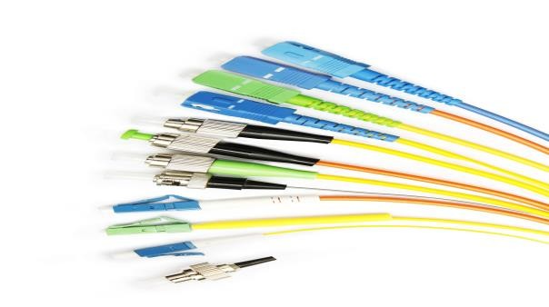
Specifications:
Applications
- Long-haul, Metro and Access System
- Fiber CATV and Fiber Network System

Parameter | Unit | Value
Connector Type |  | FC/UPC、FC/APC、SC/UPC、SC/APC、LC/UPC、LC/APC、ST/PC、 MPO
Fiber Type |  | Multi-Mode | Single Mode
Insertion Loss | dB | Typ.≤0.1 Max.≤0.2 | Typ.≤0.1 Max.≤0.3
Return Loss (Typ.) | dB | ≥36 (no APC connector) | /PC | /UPC | /APC
 |  |  | ≥45 | ≥50 | ≥60
Repeatability | dB | ≤0.1
Interchangeability | dB | ≤0.2
Connection Durability | times | ≥1000
Operating/Storage Temperature | ℃ | -40～+80

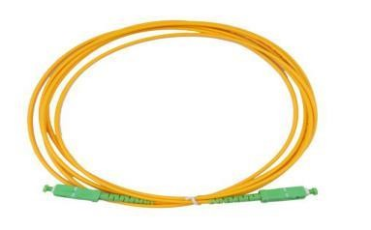 | 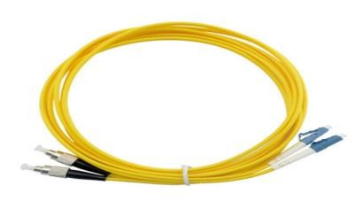 | 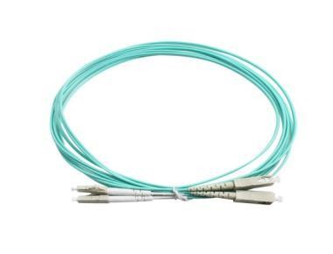
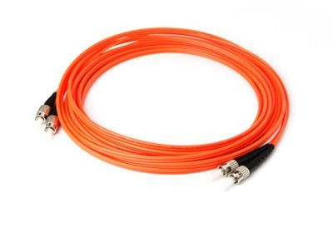 | 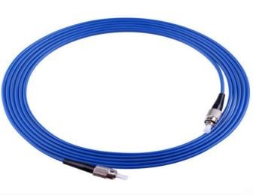 | 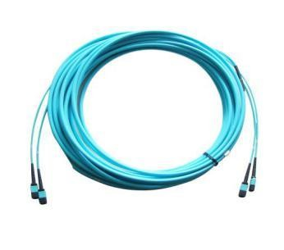

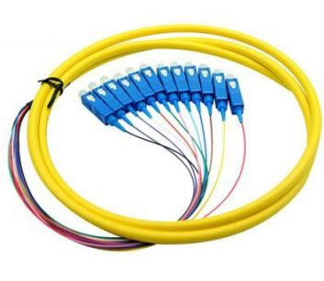 | 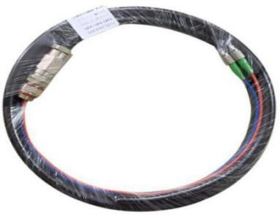 | 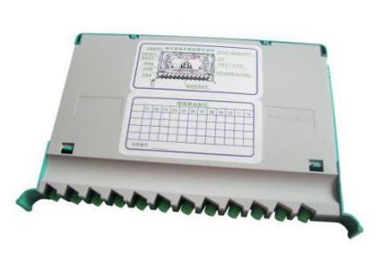

Fiber optic adapter

Fiber optic adapter can be inserted into different types of fiber optic connector. Achieve the conversion of different interfaces like SC, FC, LC, ST,MPO.

Features

- Zirconia ceramic ferrule with high durability and reliability.

- UPC/APC type available

Applications

- Telecommunication networks.

- CATV systerm

- FTTH(fiber to the home)

Specifications:

Connector Type | FC, SC, ST, LC, MPO, MTRJ etc.
Operating Wavelength | 1260nm-1650nm
Insertion Loss | ≤0.2dB, max 0.3dB
Return Loss | PC≥45dB ,UPC≥50dB,APC≥65dB
Exchangeability | ≤0.20dB
Vibration | 10-60Hz, 1.5mm ≤0.10dB
Tensile | ≤0.10dB (0-15Hg, except Ø0.9mm)
Plug times | >1000 (Times), ≤0.20dB
Storage Temperature | -40°C ~ +85°C
Operating Temperature | -40°C ~ +85°C
Relative humidity | 95%, (+25°C~ +65°C, after 100h)

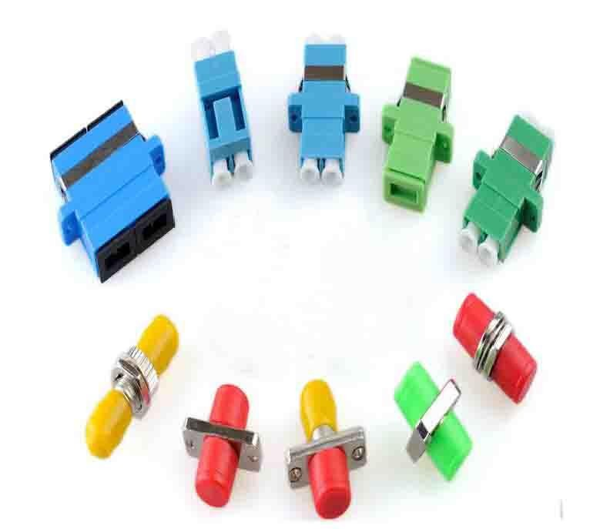

Optical Wavelength Division Series Fused WDM
Wolon’s 1310/1550nm WDM has high wavelength isolation and wide operating bandwidth.

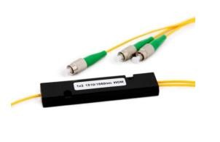
Features

  - Low Insertion loss
  - High Isolation
  - Low Polarization Dependent Loss
  - Qualified Under Telcordia GR-1221 and GR-1209

Apllications

  - Fiber Amplifier
  - Telecommunication
  - CATV Fiber Optic Link

Specifications:

Type | Unit | Specification
Port Configuration |  | 1X2 or 2X2
Grade |  | P
Type |  | A | B
Max. Insertion Loss | dB | 0.3 | 0.6
Isolation | dB | ≥16 | ≥30
PDL | dB | ≤0.1 | ≤0.1
Operating Wavelength | nm | 1310/1550±15
Directivity | dB | ≥55
Return Loss | dB | ≥55
Operating Temperature | ℃ | -20～+70
Storage Temperature | ℃ | -40～+85

Note: All the data above does not include connectors.Order Information

1310&1490&1550 Filter WDM
1310/1490/1510 WDM Devices Based on Thin-film Filter Technology are Designed to Address the Specific Requirements of the FTTx Market. Strong Coating and Passive Packaging Capabilities Feature.
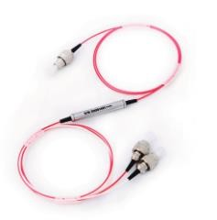
Features
- Low Insertion loss

- High Channel Isolation

- Low Polarization Dependent Loss
Applications
- Fiber Amplifier

- Long-hual,Metro,Access and FTTx

- CATV Fiber Optic Links

Specifications:

Parameter |  | Unit | Value
Operating Wavelength | 1310 Band | nm | 1260~1360
 | 1490 Band | nm | 1480~1500
 | 1550 Band | nm | 1540~1560
Insertion Loss | Com→Ref | dB | ≤0.6（Typ.0.4）

 | Com→Pass | dB | ≤0.8 (Typ.0.6)
Isolation | Com→Ref | dB | ≥15
 | Com→-Pass | dB | ≥30
PDL |  | dB | ≤0.1
Return Loss |  | dB | ≥45
Directivity |  | dB | ≥50
Operating Temperature |  | ℃ | -5~+70
Storage Temperature |  | ℃ | -40~+85

Note: All the data above does not include connectors

CWDM
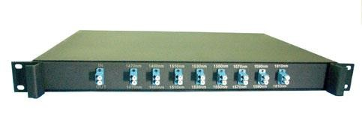
Coarse Wavelength Division Multiplexer (CWDM) Utilizes Thin Film Coating Technology and Proprietary Design of Non-flux Metal Bonding Micro Optics
Packaging.

Features
- Low Insertion Loss

- Wide Pass Band

- High Channel Isolation

- High Stability and Reliability

- Epoxy Free on Optical Path
Applications

- WDM Network

- Telecommunication

- Cellular Application

- Fiber Optical Amplifier

- CATV Systems

Specifications:

Parameter |  | Unit | Value
Channels Number |  | ch | 2 | 4 | 8 | 16 | 18
Central Wavelength |  |  | ITU-T Grid
Bandwidth(@0.5dB Passband) |  | nm | ≥14
Channel Passband |  | nm | λITU±6.5
Ripple |  | dB | ≤0.3
Insertion Loss | Typ. | dB | 1.2 | 1.6 | 2.2 | 3.2 | 3.8
 | Max. | dB | 1.4 | 1.8 | 2.8 | 5.0 | 5.6
Polarization Dependent Loss |  | dB | ≤0.10 | ≤0.15 | ≤0.20 | ≤0.25 | ≤0.30
Adjacent Channel Isolation |  | dB | ≥30
Non-adjacent Channel Isolation |  | dB | ≥45
Return Loss |  | dB | ≥45
Directivity |  | dB | ≥50
Operating Temperature |  | ℃ | -5 ～ +70
Storage Temperature |  | ℃ | -40 ～ +85
Note: 1.All the data above does not include connectors. 2.Available in LGX box and Rack Mount package

DWDM

Dense Wavelength Dividion Multiplexing(DWDM)is a Technology That Puts Data Different Sources Together on an Optical Fiber,with Each Signal Carried at the Same Time on Its Own Separate Light Wavelength.

Features
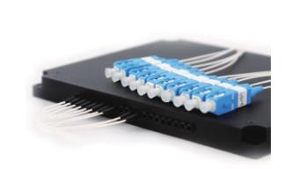
- 100GHz/200GHz ITU Channel Spacing
- Low Insertion Loss
- Wide Pass Band
- High Channel Isolation
- High Stability and Reliability
- Epoxy Free Optical Path

Applications
- Channel Add/Drop

- DWDM Network

- Wavelength Routing

- Fiber Optical Amplifier

- CATV Fiber Optical System
Non-adjacent ChanPnealraIsmoelatteior n (dB)
RetuPrnroLdouscst (TdyBp)e
2
4
≥V4a5lue
≥845
16
32
40
Directivity(dB)
Central Wavelength
ITU-T Grid
Passband@0.5dB(nm)
Passband(nm) Passband Flatness(dB)

Insertion Loss (dB)
Typ.
Max.
PDL (dB)
Adjacent Channel Isolation (dB)
1.4
1.5
≤0.15
2.0
2.2
≤0.15
≥50
≥0.3 λITU±0.11
≤0.5 2.4
3.0
≤0.15
≥25
3.5
4.5
≤0.20
4.8 5.2
5.5 6
≤0.30 ≤0.30
Operating Temperature(℃) | -5～+70
Storage Temperature(℃) | -40～+85

Specirications:
Note: 1. All the data above does not include connectors; 2. Device package is available

Optical fiber distribution frame
Optical fiber distribution frame is the equipment for fiber communication room.

Material

Cold rolled steel

Applications

  - It can fix the optic cable and protect the connection between cables and pigtails

  - The box is unique structure, reasonable layout. It’s easy installation and convenient maintenance

  - There is clear identification. Easy for transfer, jumper and test.

Specirications:

Operating temperature | -5°C +40°C
Relative humidity | ≤90% (when the temperature is below 30°C)
Atmosphere pressure | 70Kpa – 106Kpa
Storage temperature | -40°C - +70°C
Insertion loss | ≤0.20dB
Return loss | PC≥45dB ,UPC≥50dB,APC≥60dB
Durability | >1000times
Insulating resistance | ≥1000 MΩ 500V
Voltage-resistance strength | Under the effect of 3000V, 1min, non-puncture, and no arc-over
Wavelength | 850nm, 1310nm, 1550nm

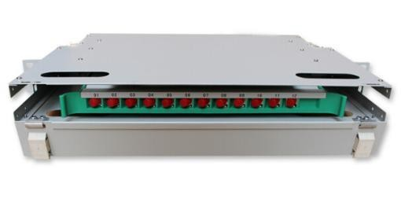 | 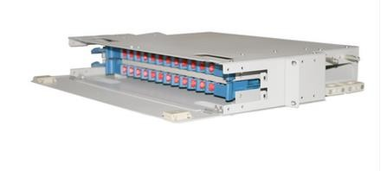 | 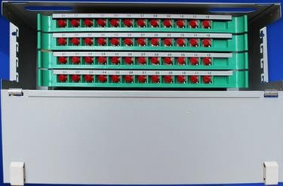
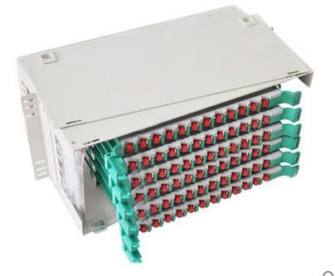 | 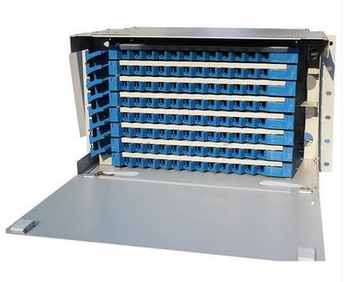 | 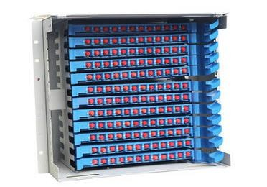

Fiber optic splice closure

Fiber optic splice closures are widely apply for the connecting of optical cable.It Suitable for straight-through, diverging and connection of FTTH. FTTB all kinds of optical communication passive network.

Features

  - Ageing resistance & ultraviolet radiation resistance
  - Advanced internal structure design
  - Easy and fast to fix fiber cable
  - Easy and fast to increase and reduce.
  - The closure is spacious enough for winding and storing fibers

Applications

  - Used for direct transmission of outdoor cable in aerial, duct and direct buried application Used for branching connection and protect the joint

Specirications:

  - Environmental Temperature: -40ºC~+60ºC

  - Air Pressure: 70~106KPa

  - Tensile Strength: >1000N

  - Pressure: >2000N/10cm2, 1min

  - Insulation Resistance: >2×104MΩ

  - Voltage Resistance: under 15KV DC and 1 min, no puncture, no arc-over

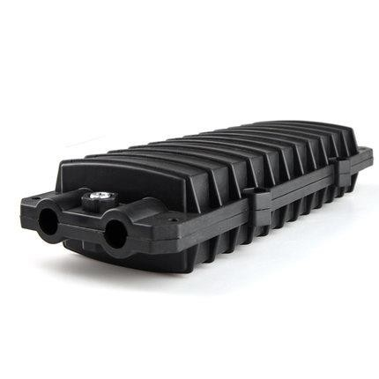 | 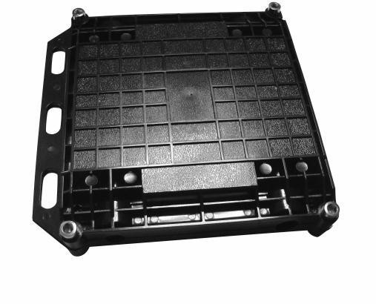 | 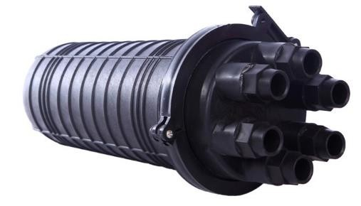

Optical Fiber termination box

Applications:

The Optical fiber termination box terminates up to optic cable and fiber pigtails protectively, and also terminates up to optic cable and optic communication device.

Technical Character

  - Made of cold-rolling steel, static spreading-plastic, color and lustre is uniform, elegant appearance, easy for operation.
  - The box has a pothook, which is convenient to install and dismantle.

  - The splice tray could be piled one upon another, flexible to turn; the curve radius of the cooled spear fibers should be guaranteed to be over 37.5mm in the splice tray.
  - The box is of unique structure, reasonable layout, and has adequate room for operation.

  - Adjustable clamp seal ring and reinforce configuration, which could adjust different sizes of cables flexibly to make sure the cables are clamp tightly.
  - The indoor type is of excellent seal performance, which could prevent water from entering effectively.

Specirications:

  - Environment temperature: -25℃ ~+40℃

  - Insulation resistance: >2*104MΩ
  - Humidity:≤85%（at 30℃)
  - Voltage Strength: 15KDC/1min, no arc-over or breakdown
  - Air Pressure:70kPa - 106kPa
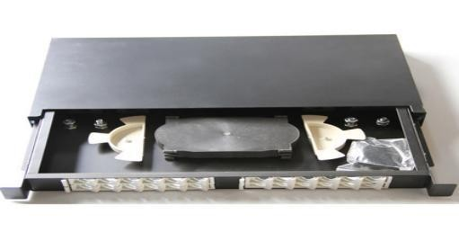 | 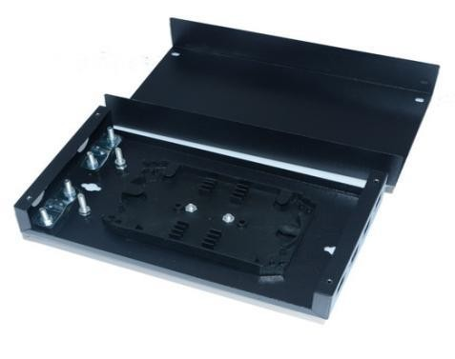 | 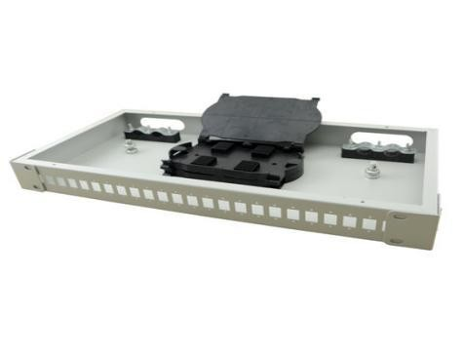

Optical Fiber Splitter Box
Fiber optic splitter box is suitable for protective connection of fiber cables and pigtails in FTTH. Widely used in the residential buildings, to fix and splice with pigtails; Can be installed on the wall; May adapt variety of optical connection styles;

Features

- The high strength plastic, resistant to rain, For indoor and outdoor wall mount or pole mount

- All-optical Structure

- Hi-reliability

- Low Insertion Loss, High Return Loss

- Good stability and reliability

Applications

- Optical LAN & WAN & CATV

- FTTH project & FTTX

- Testing instruments

- Optical fiber communication networks

- PON Networks

- Optical Signal Distribution

Specifications:

Operating temperature: | -40°C - +70°C
Storage temperature: | -40°C - +70°C
Relative humidity: | ≤90% (when the temperature is below 30°C)
Atmosphere pressure | 62Kpa – 106Kpa
Insulating resistance: | ≥2x104 MΩ / 500V (DC)
Insertion loss: | IL≤0.30dB(PC),IL≤0.30dB(APC)
Return loss: | PC≥40.0dB ,UPC≥50.0dB,APC≥60.0dB

Interchangeability | ≤0.20dB

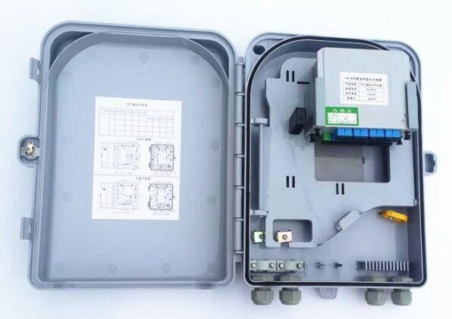 | 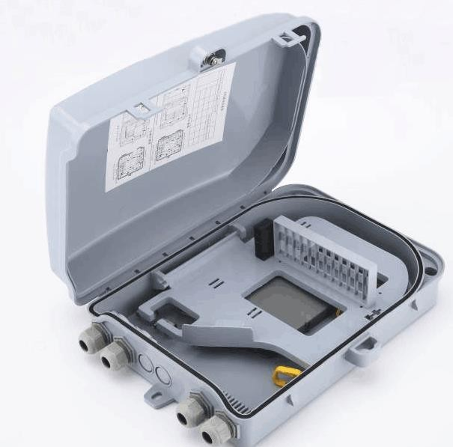

Optical cable cross connection cabinet
Fiber optic cross connection cabinet is an outdoor optical equipment that especially designed for outdoor optical fiber access network. Achieve the optical fiber connection, splicing, storage and distribution. It has two kinds of installation methods: floor mounted and aerial

Features

  - 1. Standard case body, made of high intensity, anti-corrosive, anti-aging special composite material(SMC), adapting various bad weather condition, with reliable sealing, water-proof and damp proof.
  - 2. Single/double door, dust proof and water proof. And protection level: 1P65
  - 3. Good design for inner structure, easy installation.
  - 4. Clear indication of splicing and distribution.
  - 5. The adapter can be ST, FC, SC etc.
  - 6. Enough fiber routing and storage space inside.
  - 7. Reliable cable fixation device and grounding device.
  - 8. Good design of splicing routing and guarantee bending radius of fiber optic.

Specirications:

  - Environmental Temperature: -40ºC~+60ºC

  - Relative Humidity: :≤95% (+40ºC)

  - Atmosphere pressure: 70Kpa – 106Kpa

  - Operating wavelength:1260 ~1650NM

  - Connector Loss (included repeatability and exchangeability ): ≤0.50dB

  - Insertion loss: ≤0.20dB.

  - Return loss: PC≥45.0dB ,UPC≥50.0dB,APC≥60.0dB

  - Insulating resistance: ≥2×104MΩ/500V (DC)

  - Voltage-resistance strength:≥3000V(DC),1 min no puncture, no arc-over.

  - Static loading-bearing capacity: the cover ≥980N, the side surface≥980N, the door hinge ≥200N

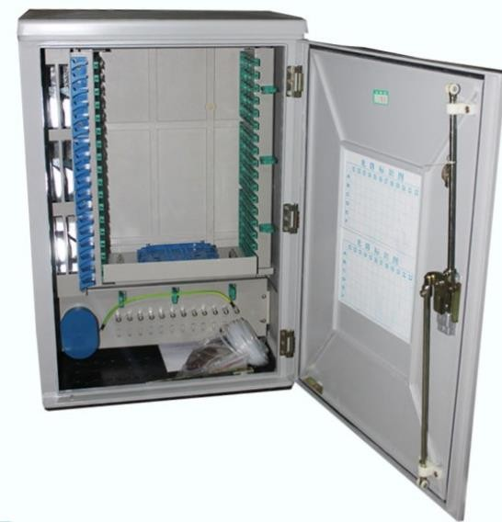 | 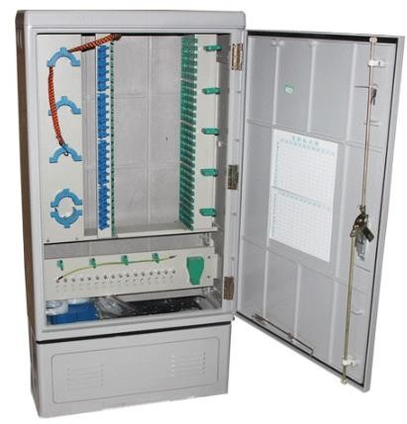

Optical Cable Series

Indoor Simplex Optical Cable

Excellent 900µm Tight Buffered Fiber with High Performance Flame Retardant Outer Security Material, and Using High Strength Aramid as the Center Strengthening Unit to Ensure the Long-term Stability of Fiber Transmission and Zero Tensile Strain.

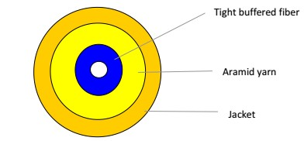

Features

    - Low Fiber Attenuation

    - Flame Retardant, Easy Strip, Easy Laying

    - Zero Tensile Strain Ensured

Applications

    - Indoor Horizontal and Vertical Wiring

    - Pigtail of Communication Equipment and Flexible Connection

    - Fiber Optical Movable Connector

Specifications:

Cable Code | Fiber Count | Cable Size (mm) | Cable Weight (kg/km) | Mini.Bending Radius (mm) |  | Tensile Strength (N) |  | Crush Resistance (N/100mm) |  | Range of Temperatur e  (℃)
 |  |  |  | Dynamic | Static | Short Term | Long Term | Short Term | Long Term
SXC16 | 1 | 1.6 | 2.9 | 60 | 30 | 60 | 30 | 500 | 100 | —20～＋60
SXC18 | 1 | 1.8 | 3.2 | 60 | 30 | 80 | 40 | 500 | 100
SXC20 | 1 | 2.0 | 3.5 | 60 | 30 | 100 | 60 | 500 | 100
SXC24 | 1 | 2.4 | 5.0 | 60 | 30 | 100 | 60 | 500 | 100
SXC28 | 1 | 2.8 | 5.8 | 60 | 30 | 150 | 80 | 500 | 100
SXC30 | 1 | 3.0 | 6.8 | 60 | 30 | 150 | 80 | 500 | 100
Fiber Type |  | G652D | 50/125 | 62.5/125 | G657A1 | G657A2 | OM3-150 | OM3-300 | OM4
Jacket Material |  | PVC |  | LSZH |  |  | TPU

Indoor Duplex Optical Cable
Excellent 900µm Tight Buffered Fiber with High Performance Flame Retardant Outer Security Material, and Using High Strength Aramid as the Center Strengthening Unit to Ensure the Long-term Stability of
Fiber Transmission and Zero Tensile Strain.
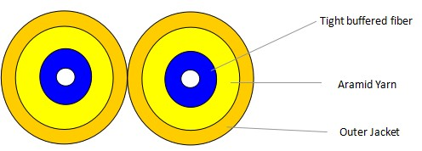

Features

- Low Fiber Attenuation

- Flame Retardant, Easy Strip, Easy Laying

- Zero Tensile Strain Ensured

Applications

- Indoor Horizontal and Vertical Wiring

- Pigtail of Communication Equipment and Flexible Connection

- Fiber Optical Movable Connector

Specifications:

DXC16 | 1 | 1.6x3.3 | 5.7 | 60 | 30 | 120 | 60 | 500 | 100 | —20～＋60
DXC18 | 1 | 1.8x3.7 | 6.7 | 60 | 30 | 160 | 80 | 500 | 100
DXC20 | 1 | 2.0x4.1 | 8.2 | 60 | 30 | 200 | 100 | 500 | 100
DXC24 | 1 | 2.4x4.9 | 9.0 | 60 | 30 | 200 | 100 | 500 | 100

DXC28 | 1 | 2.8x5.7 |  | 13.2 |  | 60 |  | 30 |  | 250 |  | 160 |  | 500 |  | 100
DXC30 | 1 | 3.0x6.1 |  | 14.2 |  | 60 |  | 30 |  | 250 |  | 160 |  | 500 |  | 100
Fiber Type |  |  | G652D |  | 50/125 |  | 62.5/125 |  | G657A1 |  | G657A2 |  | OM3-150 |  | OM3-300 |  | OM4
Jacket Material |  |  | PVC |  |  |  | LSZH |  |  |  |  |  | TPU

Drop Cable Non Self-supporting
The optical fiber unit is positioned in the center, two parallel fiber reinforced plastics FRP are placed at the two sides, the cable is completed with a black or color LSZH Sheath

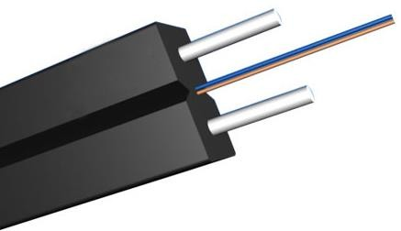
Optical Fiber 250um
FRP/Metal
LSZH/PVC Jacket

Features

- Low Fiber Attenuation

- Good Mechanical and Environmental Property, Flame Retardant, Easily Stripped

- Good Crush Resistant Protection Performance, Stable Quality

Applications

- FTTH, Indoor Horizontal and Vertical Wiring

- Fiber Interior Carpet and Corner Wiring

Specifications:

GJXFH-01 | 1 | 1.6X2.0 |  | 5 |  | 30D |  | 15D |  | 80 |  | 40 |  | 1000 |  | 500 |  | —20～＋60
GJXFH-01 | 1 | 2.0x3.0 |  | 9 |  | 30D |  | 15D |  | 80 |  | 40 |  | 1000 |  | 500
GJXFH-02 | 2 | 2.0x3.0 |  | 9 |  | 30D |  | 15D |  | 80 |  | 40 |  | 1000 |  | 500
GJXFH-04 | 4 | 2.0x4.0 |  | 12 |  | 30D |  | 15D |  | 80 |  | 40 |  | 1000 |  | 500
GJXFH-06 | 6 | 3.0X4.0 |  | 14 |  | 30D |  | 15D |  | 85 |  | 45 |  | 1000 |  | 500
GJXFH-08 | 8 | 3.0X4.0 |  | 16 |  | 30D |  | 15D |  | 90 |  | 50 |  | 1000 |  | 500
GJXFH-12 | 12 | 3.0X4.0 |  | 19 |  | 30D |  | 15D |  | 95 |  | 55 |  | 1000 |  | 500
Fiber Type |  |  | G652D |  | 50/125 |  | 62.5/125 |  | G657A1 |  | G657A2 |  | OM3-150 |  | OM3-300 |  | OM4
Outer Jacket Material |  |  | PVC / LSZH
Steel Wire

Self-supporting Drop Cable - GJYX
The optical fiber unit is positioned in the centre, two parallel fiber reinforced plastics FRP are placed at the two sides. A steel wire as the additional strength member is also applied, the cable is completed with a black or color LSZH Sheath.
FRP/Metal

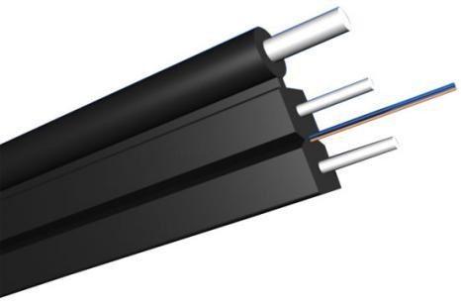
Optical Fiber
LSZH Jacket

Features

  - Bending Resistant

  - Good Mechanical and Environmental Performance, Flame Retardant,Easy Strip and Laying

  - Crush Resistance, Stable Quality

Applications

  - Indoor and Outdoor Application, Applicable to Long-distance Installation

  - Draw-In Aerially to Buildings in Cabling Network

  - Match Different Kinds of Connector

Specifications:

GJXFCH-01 | 1 | 2.0x5.0 | 18 | 60 | 30 | 600 |  | 300 |  | 2200 |  | 1000 | —20～＋ 60
GJXFCH-02 | 2 | 2.0x5.0 | 18 | 60 | 30 | 600 |  | 300 |  | 2200 |  | 1000
GJXFCH-04 | 4 | 2.0x6.0 | 21 | 60 | 30 | 600 |  | 300 |  | 2200 |  | 1000
GJXFCH-06 | 6 | 3.0X7.0 | 35 | 60 | 30 | 600 |  | 300 |  | 2200 |  | 1000
GJXFCH-08 | 8 | 3.0X7.0 | 38 | 60 | 30 | 600 |  | 300 |  | 2200 |  | 1000
GJXFCH-12 | 12 | 3.0X7.0 | 40 | 60 | 30 | 600 |  | 300 |  | 2200 |  | 1000
Fiber Type |  | G652D | 50/125 | 62.5/125 | G657A1 |  | G657A2 |  | OM3-150 |  | OM3-30 | 0 OM4
Jacket Material |  | PVC/LSZH

